|  |  |  |
| --- | --- | --- |
| |  |  | | --- | --- | | |  | | --- | | *Human Perspectives ATAR Units 3 & 4* | | |

Answers: Chapter 11 Other evidence of evolution

Questions 11.1

RECALL KNOWLEDGE

**1** What is a fossil?

*Answer*:Any preserved trace left by an organism. Fossils include bones, shells, teeth, footprints, burrows, faeces or impressions of an animal or plant.

**2** List the conditions needed for fossils to form.

*Answer*:

* Hard parts in or of the organism
* Alkaline soils
* Little to no oxygen
* Rapid burial under sediment
* Left undisturbed for a long period of time

**3** Explain why fossils are often found near lakes and rivers.

*Answer*: Sediments from the river or lake will rapidly bury or cover the organism to prevent decomposition.

**4** Why are hand tools used to dig at excavation sites rather than bigger earthmoving equipment?

*Answer*: Fossils are delicate and very small. Large earth moving equipment would damage or destroy the fossils.

**5** Describe artefacts, including at least one example.

*Answer*: An artefact is an object deliberately made by humans. They include stone tools, beads, carvings, charcoal from cooking fires and cave paintings.

APPLY KNOWLEDGE

**6** Why are fossil remains of organisms usually bones or teeth, and not the skin, muscle or organs?

*Answer*: Skin, muscles and organs are soft and are easily decomposed or scavenged. Hard parts, including bones and teeth, will contain minerals that will not dissolve and contain a matrix to allow lime or iron oxide to replace the organic material of the structures, petrifying them.

**7** Fossils of soft tissue are most likely to be found in acidic soil, while the best fossils of bones are found in alkaline soils. Explain why this occurs, and include any other conditions that must be present for each of these fossils to form.

*Answer*: Acidic soil that also contains no oxygen, for example peat or tar, will preserve soft tissue and bones. Bones buried in alkaline soils will not have their minerals dissolved. Inorganic minerals, such as lime and iron oxide, will replace the organic material in the bone matrix, petrifying the bone and retaining its shape.

Questions 11.2

RECALL KNOWLEDGE

**1** Describe the difference between absolute dating and relative dating.

*Answer*: Relative dating provides a comparison between fossils to determine which is older or younger, no actual age is determined. Absolute dating determines an actual age of the specimen in years.

**2** Define ‘isotopes’ and list three isotopes of potassium.

*Answer*: Isotopes are atoms of the same element with different numbers of neutrons. The three isotopes of potassium are potassium-39, potassium-40 and potassium-41.

**3** Explain how the amount of potassium-40 can provide information about the age of the sample.

*Answer*: Potassium-40 is a radioactive isotope, it will decay into calcium-40 and argon-40. By measuring the amount of potassium-40 and argon-40 in a rock sample it is possible to calculate the age of the rock. As the rock ages, the proportion of potassium-40 decreases and the proportion of argon-40 increases.

**4** What types of samples are able to be dated using potassium–argon dating?

*Answer*: Rocks, of volcanic origin that are at least 100 000 – 200 000 years old.

**5** What types of samples are able to be dated using carbon-14 dating?

*Answer*: Organic samples that are less than 70 000 years old.

**6** Define ‘half-life’ and state the half-life of carbon-14 and potassium-40.

*Answer*: Half-life is the time required for half of any quantity of radioactive material to decay into stable non-radioactive material. The half-life for carbon-14 is 5730 years ± 40 years. The half-life for potassium-40 is 1250 billion years.

**7** What type of dating could be used to determine the age of a wooden artefact?

*Answer*: Carbon-14 would be used as the wood is organic, provided the artefact is less than 70 000 years old.

**8** Explain why the principle of superposition cannot be considered without taking other factors into account.

*Answer*: The principle of superposition assumes the layers of sedimentary rock are not disturbed through Earth crust distortions or through human activities of burial or mining.

**9** Describe index fossils and explain their relevance to relative dating.

*Answer*: Index fossils are fossils that were widely distributed and present on Earth for a limited period of time. They are used in correlation of rock strata and improve the reliability of relative dating of strata. If an index fossil is found in two strata layers, it can be confirmed that these strata layers are of the same age, even if they were located thousands of kilometres away from each other.

**10** List the reasons that there are gaps in fossil records.

*Answer*:

* Fossils are hard to form. Certain conditions must be fulfilled for fossilisation to occur.
* Fossils are hard to find. Some are buried too deep underground or are inaccessible.
* Fossils are hard to classify. They may not have been recognised as a fossil and been discarded.
* Fossils are hard to preserve. Fossils have been destroyed by Earth’s crust movement, or human activity.
* Fossils are hard to date. In order to place the fossils on the fossil record, the age of the fossil must be determined.

APPLY KNOWLEDGE

**11** Compare and contrast atoms of potassium-40, calcium-40 and argon-40. Use this to suggest what happens when potassium-40 decays to form calcium-40 and argon-40.

*Answer*:

Compare: All atoms contain protons, neutrons and electrons. They also have a similar mass number around 40.

Contrast: the number of protons and neutrons differs for each atom. K-40 has 19 protons and 21 neutrons. Ca-40 has 20 protons and 20 neutrons and Ar-40 has 18 protons and 22 neutrons.

When Potassium-40 undergoes beta-decay, one neutron is converted to a proton, changing the atom to Ca-40. This occurs about 89% of the time. Around 11% of the time, K-40 undergoes electron capture which converts a proton to a neutron, changing the atom to Ar-40.

**12** Explain why dating using carbon-14 is also called radiocarbon dating.

*Answer*: Carbon-14 is a radioactive isotope of carbon. The dating method relies on the decay of C-14 to nitrogen.

**13** Explain why carbon-14 dating can only be used to determine the age of samples that were once living.

*Answer*: Carbon-14 is formed in the upper atmosphere and enters the food chain through the process of photosynthesis converting the C-14 in the carbon dioxide molecule into a glucose molecule. The glucose is then consumed, and the C-14 isotope is assimilated into the body tissues of the organism. Once the organism dies the C-14 decays into nitrogen and the ratio of C-14 to C-12 can be measured.

**14** The diagram below shows a sample of soil taken from the same area. The colours represent fossils found in particular layers. State the age of the fossils from the youngest to the oldest.

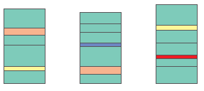

*Answer*:

Blue is the youngest, then orange, yellow and red is the oldest fossil.

Questions 11.3

RECALL KNOWLEDGE

**1** Define ‘homologous structures’ and ‘vestigial structures’.

*Answer*: Homologous structures are structures that have a similar structure but not necessarily a similar function. Vestigial structures are a structure of reduced size that appears to have no function.

**2** Describe how comparing the structure of embryos at different stages of development can provide evidence for evolution.

*Answer*: Embryos develop along similar lines and show similarity between different species at different times. The similarities indicate a common ancestor.

**3** Describe how a comparison of homologous structures provides evidence for evolution. Include an example in your explanation.

*Answer*: Homologous structures, for example the vertebrate forelimb, show similar bone structures. The genes controlling them have been conserved between the different species, and despite dissimilar functions, display a related pattern to the structure. This indicates a common ancestry.

**4** List five vestigial structures of humans.

*Answer*:

* Nictitating membrane
* External ear muscles
* Wisdom teeth
* Pyramidalis muscles
* Coccyx bones
* Appendix
* Muscles at the base of hairs

APPLY KNOWLEDGE

**5** Explain the importance of fossils in providing evidence for evolution.

*Answer*: Fossils are preserved traces of organisms that once were alive. They help show the transition in physical characteristics that can be attributed to the gradual genetic change in a species. Evolution is defined as the gradual genetic change in a species over many generations. Fossils provide physical evidence to show the gradual changes in species.

**6** Explain how our developing understanding of the functions of the appendix has led some scientists to believe that it is not a vestigial structure.

*Answer*: The appendix was thought to only have a digestive function, due to its location as an additional blind sac to the caecum. It is now known to have an endocrine function in foetal development, containing endocrine cells to make amine and peptide hormones. In young adults, the appendix accumulates lymphoid tissue and acts as a lymphoid organ, maturing B lymphocytes and in the production of immunoglobulin A antibodies. Scientists believe that it is not a vestigial structure, due it is current function.

Questions 11.4

RECALL KNOWLEDGE

**1** Define ‘phylogenetic tree’.

*Answer*: A phylogenetic tree is a diagram showing evolutionary relationships between related organisms. It is also called a dendrogram.

**2** Describe what phylogenetic trees are used for.

*Answer*: They are used to show probable relationships between a group of organisms derived from a common ancestor.

APPLY KNOWLEDGE

**3** Suggest why phylogenetic trees are so named.

*Answer*: Phylogeny is the study of relationships among different groups of organisms. The relationships are drawn like branches on a tree, the main trunk deriving from the common ancestor and the branches showing divergence.

**4** Consider the phylogenetic tree for cats shown below.

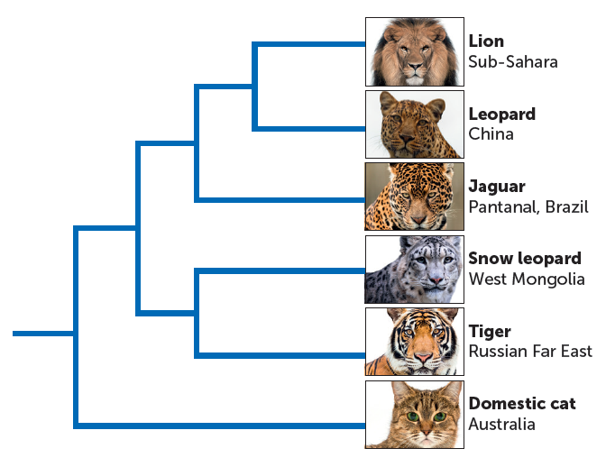

**a** Which cats have the most recent common ancestor?

*Answer*: The lion and the leopard.

**b** Do tigers or jaguars have a more recent common ancestor with lions?

*Answer*: The jaguar has a more recent common ancestor to the lion.

**c** Suggest why the domestic cat has more differences than the other cats.

*Answer*: Domestic cats have been artificially selected and deliberately bred for particular characteristics desired by humans. They have not been affected by environmental factors and are significantly smaller and tamer than the other big cats.

**5** Use the fictional values comparing four species named A, B, C and D to construct a phylogenetic tree.

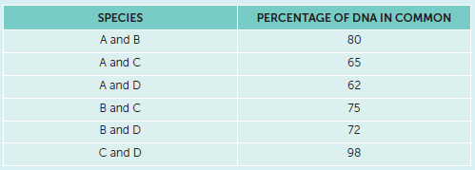

*Answer*:

Students trees may vary.

C and D need to be the closest. A and B also need to show a close relationship.

A suggestion is shown below.

**A** **B** **C** **D**

Chapter 11 Activities

ACTIVITY 11.1 Investigating radioisotope methods of dating

A RADIOCARBON DATING

**What to do**

**1** Draw up a table like the one below and fill in all the gaps.

*Answer:*

|  |  |  |
| --- | --- | --- |
| **Half-life** | **Age (years)** | **Radioactivity (nuclei/s/g)** |
| 0 | 0 | 15.6 |
| 1 | 5730 | 7.8 |
| 2 | 11 460 | 3.9 |
| 3 | 17 190 | 1.95 |
| 4 | 22 920 | 0.975 |
| 5 | 28 650 | 0.4875 |
| 6 | 34 380 | 0.24375 |
| 7 | 40 110 | 0.121875 |
| 8 | 45 840 | 0.0609375 |
| 9 | 51 570 | 0.03046875 |
| 10 | 57 300 | 0.015234375 |

**2** On your sheet of graph paper, plot a decay curve for carbon-14 to show the relationship between decay rate and time, up to a maximum of 60 000 years.

*Answer:*

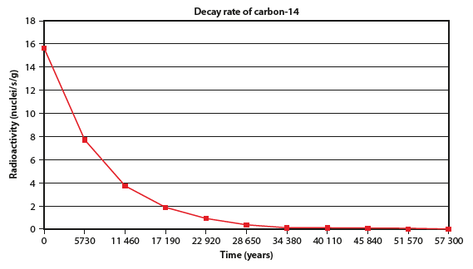

**3** Use your graph to answer the following questions.

**a** Charcoal remains from a hearth in a cave occupied by Australian Aborigines were found to have a decay rate of 8.9 nuclei/s/g of charcoal. How old was the charcoal?

*Answer:* Approximately 4500 years old. (This figure will vary depending on the accuracy of the graph and whether students have plotted a smooth curve or ruled straight lines between the points.)

**b** A piece of wood buried in a cave in Europe was found alongside stone tools that were considered to be about 9000 years old. If the wood were the same age as the tools, what decay rate would you expect from the piece of wood?

*Answer:* Approximately 5 nuclei/s/g

**c** If the piece of wood from question **b** was found to be considerably older than 9000 years, what explanations can you offer for the fact that it was at the same level in the cave deposits as the tools?

*Answer*: Animals or humans could have buried the tools; or there could have been disruption to the burial process or site of both the tools and wood.

**d** If the piece of wood was found to be considerably younger than 9000 years, suggest reasons to account for the fact that it was at the same level in the cave deposits as the tools.

*Answer*: Animals or humans could have buried the wood; or there could have been disruption to the burial process or site of both the tools and wood.

**e** A fossil bone was discovered and when tested had a decay rate of 1.5 nuclei/s/g. How old was the fossil bone?

*Answer*: Approximately 20 000 years old

**f** A piece of fossilised wood was dated using the tree-ring method at 4000 years old. What decay rate would you expect it to display when it was subject to carbon-14 analysis?

*Answer*: Approximately 10.2 nuclei/s/g. Around 10 would be acceptable, possibly even a little less.

B POTASSIUM–ARGON DATING

**What to do**

**1** Explain why there is no argon-40 in layer A.

*Answer*: The rock is not old enough. The radioactive potassium decays too slowly to have enough argon-40 to detect in a rock of this age.

**2** Determine the ratio of potassium-40 to argon-40 in layer E.

*Answer*: 7:2 = 3.5: 1

**3** Rock layers B, D and F are composed of the same material. What type of material do you think this would be? Explain how it has come to be between the alternating layers of lava.

*Answer*: Layers B, D and F would be sedimentary rock, which has formed by the compaction of wind or water-borne sediments over a long period of time. Later, further eruptions of the volcano resulted in these sediments being covered by lava.

**4** Explain why there are no fossils in layers A, C, E and G.

*Answer*: These are lava layers. The lava would have been so hot that it destroyed any remains of organisms, thus no fossils were preserved.

**5** Layers B, D and F all contain fossils. For this to have occurred, conditions must have been suitable for fossilisation. Describe the conditions that assist the process of fossilisation.

*Answer*: Fossilisation requires rapid burial and preferably alkaline soils.

**6** Anthropologists working at this site believe that layer B was formed around 40 000 to 70 000 years ago. This date is too early to use the potassium–argon dating technique. Suggest at least two ways in which they could determine the age of layer B. Explain how each of these methods works.

*Answer*: Fossils in layer B that contained carbon could be dated by carbon-14 dating. This method of dating material is based on the decay of the radioactive isotope of carbon, carbon-14, to nitrogen. Measuring the amount of radiation liberated by a sample of organic material, the ratio of carbon-14 to carbon-12 can be estimated, and from this, the age of the sample can be calculated. It is only useful for material younger than 70 000 years, but because layer B is within that range, this technique could be used to date fossil material contained within it.

Fission tracks are a radioactive type of dating. The rocks must contain uranium-bearing minerals or glasses. Fission tracks are created in the surrounding minerals when the uranium decays. It is possible to tell how much time has passed since the tracks began. The method can be used to date minerals that are one hundred years to four thousand five hundred million years old.

ACTIVITY 11.2 Investigating stratigraphy

**What to do**

**1** How do you think these sediments were formed?

*Answer*: Sedimentation would have occurred over many millions of years. Some layers would have been beneath the sea at some time. Changes in sea level may have resulted in some layers being exposed, then covered again by water. Some layers appear to contain fossils that were terrestrial and therefore may have been buried by wind-borne sediments, or by silt deposited by rivers. Such fossils may have also resulted from human or animal burial. A clear fault line is visible, so Earth movements have occurred.

**2** The various layers in series A and series B no longer align with each other. Explain how this may have happened.

*Answer*: A shift in the Earth’s crust, such as an earthquake, creating a clear fault line, is the most likely explanation.

**3** Of all the strata shown in series A, B and C, which is the oldest? Explain how you arrived at your answer.

*Answer*: According to the principle of superposition, the oldest layer is at the bottom of each series, therefore layer 7 of series A is the oldest layer. Series C has the youngest strata, because layer 8 of this series correlates with layer 3 of series B; in turn, layer 6 of series B is younger than most strata in A, because layer 6 of series B correlates with layer 2 of series A.

**4** Of all the strata shown, which is the youngest? Explain how you arrived at your answer.

*Answer*: Layer 1 of series C. This was obtained by matching the layers that were the same and then seeing which layer was at the top.

**5** Layers A2 and B6, and B1 and C6, contain the same types of fossils. Would these be index fossils? List the criteria that must be met for a fossil to be considered an index fossil.

*Answer*: They are not likely to be index fossils, because index fossils need to be widely distributed and are only present on Earth for a short period of time.

**6** A fossil in layer A4 was dated at 45 000 years using carbon-14 dating. What can you infer about the relative ages of layers B6 and C8?

*Answer*: Layer B6: less than 45 000 years old. Layer C8: very much younger than B6; far more recent.

**7** Could layer A6 be dated using the potassium–argon technique? Give reasons for your answer.

*Answer*: Only volcanic rock more than 100 000 years old can be dated using potassium-argon. Because this stratum is much deeper than layer A4, dated at 45 000 years, it is possible that it would be of an age suitable for this technique. However, since only igneous rocks can be dated by this method, it is unlikely that it could be used.

**8** Do you think dendrochronology could be used to determine an absolute date for layer C2? Give reasons for your answer.

*Answer*: Dendrochronology could be used for layer C2, because it contains wood and it is a layer that is much younger than 45 000 years.

ACTIVITY 11.3 Investigating phylogenetic trees

**What to do**

**1** Refer to Table 10.2 in Chapter 10 (page 280), which shows the relationship between humans and great apes using DNA differences. Using this information, construct a phylogenetic tree to show diagrammatically the evolutionary relationships.

*Answer*:

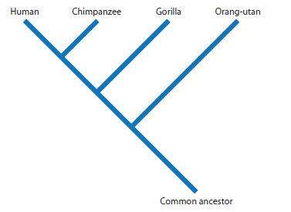

**2** Refer to Table 10.4 in Chapter 10 (page 283). This table shows the differences in amino acids in cytochrome C between humans and a number of other species. The more similarity there is between two molecules, the more recently they have evolved from a common ancestor. Using this information, construct a phylogenetic tree to show the evolutionary relationships between the species listed.

*Answer*:

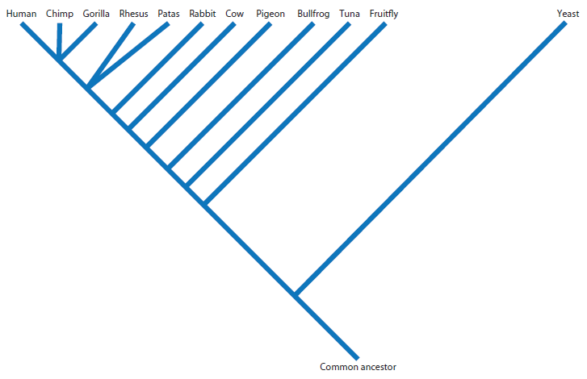

**3** Refer to Table 10.5 in Chapter 10 (page 285), which shows the amino acid sequences in the haemoglobin of five mammalian species. Using the data presented in the table, construct a phylogenetic tree to show the evolutionary relationships between the species shown.

*Answer*:

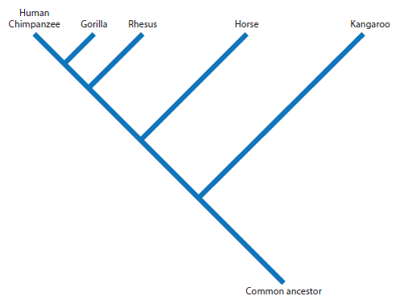

**Studying your data**

**1** How much variation was there among the phylogenetic trees constructed by different class members? Explain any similarities and differences with the ones you have created.

*Answer*: Responses will vary widely.

**2** In the three trees you have drawn, does one animal appear to be more closely related to humans?

*Answer*: In all three of the trees, the chimpanzee should be the species most closely related to humans.

**3** In which of the three trees do you have the most confidence as a good representation of evolutionary relationships? Why did you select this tree?

*Answer*: Responses will vary, but most students will probably suggest the first as it is based on DNA differences and it appears to resemble many of the current phylogenetic representations found in the literature.

**4** When a phylogenetic tree is constructed, it can be considered a way of presenting a hypothesis. Explain why.

*Answer*: A hypothesis is a possible explanation to account for observations and, in constructing a phylogenetic tree, it is a diagrammatic representation of observations that have been made, or it is based on data that has been collected.

Chapter 11 Review questions

Recall

**1 a** Define ‘fossil’.

*Answer*: A fossil is any preserved trace left by an organism that lived a long time ago.

**b** Give examples of five different forms of fossils.

*Answer*: Footprints, petrified faeces, bones, teeth, shells, impressions, burrows or feeding marks.

**2 a** Explain the difference between a fossil and an artefact.

*Answer*: A fossil is a natural trace left by an organism, whereas an artefact is an object that has been deliberately made by humans.

**b** What is an index fossil? Could there be such things as index artefacts?

*Answer*: Fossils from organisms that were widely distributed geographically, and were only on Earth for a short period of time are called index fossils. These fossils are used for relative dating.

Many types of stone tools or primitive artwork can be considered to be index artefacts. They are indications of a particular culture at a particular time. (In practice, the term ‘index artefact’ is not used.)

**3 a** What soil types are best for the preservation of fossils?

*Answer*: Wet acidic soil that does not contain oxygen (for example, peat) is best for the preservation of soft tissues. Alkaline soils are best for preservation of bones, because there is no acid to dissolve the hard part of the bone.

**b** Why is it that fossilised soft tissue, such as muscle, is rarely found by those searching for fossils?

*Answer*: Soft tissues are very quickly decayed by bacteria, fungi and other micro-organisms.

**4 a** What do you understand by the terms ‘relative dating’ and ‘absolute dating’?

*Answer*: Relative dating gives a comparison of age. It indicates the age of something relative to the age of something else; that is, it will indicate which fossil, artefact or rock stratum is older than another.

Absolute dating gives the actual age of the material in years.

**b** Why is relative dating used when a number of good methods of absolute dating are available?

*Answer*: All the methods of absolute dating require certain sets of conditions to be met before the method can be used. In cases where the conditions are not met, and it is not possible to get an actual date, relative dating must be used.

**5** Draw up a table with three columns, listing in the first column the methods of absolute and relative dating described in this chapter. In the second and third columns, list the advantages and limitations of each method.

*Answer:*

|  |  |  |
| --- | --- | --- |
| **Absolute dating method** | **Advantages** | **Limitations** |
| Potassium-argon | Can be used to give precise dates | Not all rocks suitable  Only useful for rocks 100 000 to 200 000 years or older  Must have rock that is same age as fossil |
| Carbon-14 | Can be used to give precise dates Used for more recent fossils  Useful for dating artefacts, provided they contain organic material | Need 3 g of the organic material Only useful for material up to 70 000 years old  Carbon-14 varies in atmosphere, so not as reliable as once thought  Material to be dated must contain carbon |
| Accelerator mass spectrometry radio-carbon dating | Only need 100 micrograms of sample Used for more recent fossils  Useful for dating artefacts if they contain carbon | Only useful for material up to 70 000 years old  Carbon-14 varies in atmosphere so not as reliable as once thought  Must contain carbon |

**6 a** What is the principle of superposition?

*Answer*: The layers of sedimentary rock closest to the Earth’s surface are the youngest. The deeper one goes into a sedimentary deposit, the older the material.

**b** Does this principle always apply? If not, explain why.

*Answer*: No. The layers can be shifted around by earth movements. The Earth’s crust can fault and fold. Animals can bury artefacts into deeper soil layers. Human burials and other human activity may result in fossils being found in sediments older than the fossil.

**7** What are phylogenetic trees and why are they used?

*Answer*: Phylogenetic trees are a diagrammatic representation of evolutionary relationships between groups of organisms that have derived from a common ancestor. They are used to give a simple representation of complex relationships, and are useful for showing possible evolutionary pathways.

**8 a** What are homologous structures?

*Answer*: Homologous structures are structures that possess a similar structure, even though their functions may differ; for example, the forelimbs of vertebrates.

**b** Using an example, describe how homologous structures provide evidence for evolution.

*Answer*: Species with organs that have a similar structure are likely to have evolved from a common ancestor. For example, the same limb bones appear in various forms throughout the vertebrates – the forelimbs of amphibians and reptiles, the wings of bats and birds, the leg of a horse, the flipper of a whale or seal and the human arm. These similarities between the classes of vertebrates indicate that they have all diverged from a common ancestor.

**9 a** What is a vestigial organ? Describe four human vestigial organs.

*Answer*: Vestigial organs are structures that have, over the course of evolution, been reduced in size and appear to have no function. Vestigial organs possessed by humans include:

• coccyx – formed from fused vertebrae for a tail

• appendix – which is a reduced caecum that appears to have no digestive function but does has an endocrine function in foetal development and an immune function in young adults.

• wisdom teeth – not needed for chewing.

• body hair – not required for maintaining body temperature

• muscles attached to external ear – most people are no longer able to move their ears.

**b** Describe the significance of vestigial organs to the theory of evolution.

*Answer:* Vestigial structures, which appear to have no function, show that in ancestors they did function. However, over time, and as the result of changing environments, these organs were no longer necessary and their size and function gradually decreased.

Explain

**10** Explain the principle behind radioisotope methods of dating.

*Answer*: Radioactive material decays at a known rate. Radioisotope dating is based on knowing the half-life of the radioactive isotope. So knowing how much radioactive product is in the fossil and knowing its rate of decay allows the age of the fossil to be calculated.

**11** Describe why potassium–argon dating cannot be used to date fossil bones.

*Answer*: The isotope is found in rocks of volcanic origin. Any bones trapped in volcanic rock would be destroyed by the heat.

**12 a** How is it that the bodies of plants and animals have radioactive carbon-14 in them?

*Answer*: Carbon-14 is in the atmosphere and is taken up by plants when they photosynthesise. Thus, it is found in plants. These plants are consumed by animals and the carbon-14 is then incorporated into the animals’ tissues.

**b** What does it mean to say that carbon-14 has a half-life of 5730 years?

*Answer*: In 5730 years half of any sample of carbon-14 will have decayed and half will be remaining.

**c** Why is it not possible to use radioactive carbon dating on artefacts?

*Answer*: Most of the older artefacts do not contain carbon, being made from stone, so this dating technique is not suitable. However, more recent artefacts made from wood or other plant materials, would be able to be dated using radioactive carbon dating.

**d** What is AMS radiocarbon dating?

*Answer*: Accelerator mass spectrometry (AMS) radiocarbon dating breaks the sample up into all the different types of atoms that it contains. The numbers of atoms of each isotope of carbon can then be counted.

**13 a** Explain how index fossils can be used to compare strata from different locations.

*Answer*: Index fossils were widely distributed and only lived on Earth for a short time. This means that dating the strata where they are found is more precise. If the index fossil is found in rocks at different locations the rocks should be of the same approximate age.

**b** Describe the different ways in which fossil pollen grains can be of use to the anthropologist.

*Answer*: Fossil pollen grains can be of use in the following ways:

• as index fossils

• to gain a picture of the vegetation around the time that the pollen was produced by plants

• as an indicator of climatic conditions at the time the plants (that produced the pollen) were living.

**14** How does a study of embryology assist in supporting the theory of evolution? Give examples to illustrate your answer.

*Answer*: Embryology compares the early stages of development of organisms. It is useful because the embryonic stages between species are more similar than the adult stages, thus indicating evolutionary relationships. For example, all vertebrate embryos have gill arches and gill pouches, indicating that they all diverged from a common aquatic ancestor.

Apply

**15** Anthropologists excavating the floor of a cave found, at a depth of 50 centimetres, a deposit of charcoal that they concluded was the site of an ancient hearth. Next to the hearth, at the same depth, was a stone tool. Radiocarbon analysis of the charcoal showed that the ratio of carbon-14 to carbon-12 was 0.25 in 1012. Further excavation uncovered, at a depth of 95 centimetres, a fragment of human jawbone and the thigh bone of another animal.

**a** What would be the estimated absolute age of the stone tool?

*Answer*: 11 500 years (or 11 460 years, which is precisely two half-lives).

**b** What evidence would suggest that the jawbone and thigh bones were the same age?

*Answer*:They were found at the same layer, the principle of superposition indicates that fossils or artefacts found at the same layer of strata are of the same age.

**c** Further testing showed that the thigh bone was younger than the jawbone. How could this be possible?

*Answer*:The thigh bone may have been buried more recently but down to the depth of the jawbone.

**16** The sand dunes around the Australian coast consist of alkaline soil. If an animal were buried in the dunes by drifting sand, would its bones become fossilised, provided they were left undisturbed for long enough? Explain the reasons for your answer.

*Answer*: Yes. Alkaline soil does not dissolve the minerals in bone. If left for long enough, these bones should fossilise.

**17** In the peat bogs of England, Denmark and other parts of northern Europe, human bodies up to 4000 years old have been found. The hair, skin and other soft tissues have been so well preserved that the fingerprints can still be seen on the skin of the hand, and food in the alimentary canal is complete enough to indicate the nature of the last meal eaten.

**a** Describe the types of conditions that must be present in peat bogs to allow preservation of these tissues for such a long period of time.

*Answer:* Soft tissues are preserved in wet acidic soils, such as peat bogs, when there is no oxygen present.

**b** Would you expect the skeletons of these ‘bog people’ to be preserved? Why, or why not?

*Answer*: Bones of bog people are rarely preserved because the acid in the bog dissolves the calcium phosphate of the bone.

**18** Riversleigh, in north-west Queensland, is one of the world’s most important and abundant fossil sites. Fossils found at Riversleigh include kangaroos, wombats, bandicoots, possums, koalas, platypuses, crocodiles, snakes, turtles, lungfish, birds, frogs, snails and insects.

**a** From this list of some of the fossils found at Riversleigh, write a description of what the area must have been like when the fossil animals were alive.

*Answer*: Riversleigh would have been an area that had eucalyptus and other trees (habitat for koalas, possums and so on). These trees could have lined a river or a lake (crocodiles, platypuses). The river or lake may have had a swamp-like area that provided the moist conditions for frogs, insect larvae, snails and lungfish. The surrounding land could have been drier with scrub and bushes (the habitat for wombats, bandicoots and kangaroos).

**b** What conditions must have occurred at Riversleigh for so many organisms to have been fossilised?

*Answer*: The conditions would have contained alkaline soil, which would have allowed fossilisation to occur. It must have been a stable area over a long period of time to allow for the process of fossilisation to occur. Burial must have occurred rapidly, and once buried, the fossils must have been undisturbed by other animals or humans.

**19** Homologous organs are so called because they have a similar structure. However, the basic structure may be modified substantially to carry out a different function. Describe the changes that have taken place to the vertebrate forelimb for it to become:

**a** a flipper

*Answer*: In a flipper, the humerus is shortened and thickened; the shortened and thickened ulna and radius have a minimal gap between them; the phalanges are modified: 1 is reduced, 2 is lengthened, 3 is slightly reduced, and 4 and 5 are significantly reduced; all phalanges are thickened. See also the diagram of bones in a flipper in Figure 11.14 on page 307. These changes have made the bones capable of providing the strong support needed for a flipper.

**b** a wing

*Answer*: In a bat’s wing, all the bones are reduced in thickness and elongated; the metacarpals and phalanges make up the main structures of the wing that the skin is stretched across; the bones are thickened and shortened; the humerus, ulna and radius make up the main part of the wing with significantly reduced and fused metacarpals and phalanges.

In a bird’s wing, the humerus, radius and ulna are arranged in a similar way to humans, but the metacarpals and phalanges are mostly fused together to give the wing more strength. See also the diagram of bones in a wing in Figure 11.14 on page 307.

**c** an arm.

*Answer*: In a human arm, the humerus, ulna and radius are thickened and lengthened; the metacarpals and phalanges are also elongated; in humans, the first digit has developed a saddle joint so that the thumb is opposable. See also Figure 11.14 on page 307.

Extend

**20** In this chapter, the forelimb was used as an example of homologous structures. What other structures found in vertebrates could be used to illustrate homology?

*Answer*: Muscle structures and arrangements; skeletal structures other than limbs; tail bone in primates – tail and coccyx; alimentary canals. Ear bones in mammals are homologous to gill and jaw bones in fish.

**21** In 1893 a German anatomist, Robert Weidersheim, compiled a list of 86 vestigial organs. On his list were the valves in veins, the tonsils, the pituitary gland and the thymus. Why must scientists be very careful about describing an organ as vestigial?

*Answer*: They must be careful in describing an organ as vestigial in case its function has not yet been discovered. Also, the function of some so-called vestigial organs can change over time and the new function may become important to the organism.

**22** More than 135 years ago, Charles Darwin predicted that fossils of the ancestors of modern humans would be found in Africa. Suggest what evidence Darwin would have used as the basis for making that suggestion.

*Answer*: Darwin studied the relationship between species. His interpretation of the primate data at the time led him to believe that humans were related to monkeys and apes. His studies were based on physiological, anatomical and behavioural comparisons. He thought that fossils of human ancestors would be found in Africa because he considered humans to be more similar to African apes (gorillas and chimpanzees) than to Asian apes (orang-utans and gibbons).

**23** New techniques in establishing an absolute age for a fossil or artefact have been developed in recent years. Three of these are uranium–thorium dating, electron spin resonance and thermoluminescence. Find out:

**a** the principle on which these techniques are based

**b** the uses to which the techniques have been put

**c** limitations to the use of these techniques.

*Answer*:

|  |  |  |  |
| --- | --- | --- | --- |
| **Dating techniques** | **The principle** | **The uses** | **Limitations** |
| Uranium-thorium dating | Calculates an age from the degree to which secular equilibrium has been restored between the radioactive isotope thorium-230 and uranium-234. | Used to determine the age of calcium carbonate materials such as speleothem or coral.  Thorium is not found in materials that are grown from water found at or near the surface of the earth, whereas uranium is soluble and will be found in material that precipitates or is grown form natural water. | Uranium-thorium dating has an upper age limit of 500 000 years, defined by the half-life of thorium-230. |
| Electron spin resonance | ESR dating measures the amount of unpaired electrons in crystalline structures that were previously exposed to natural radiation. The age of the substance can be determined by measuring the dosage of radiation since time of its formation. | Used to date newly formed materials which radiocarbon dating cannot. Carbonates, tooth enamel or igneous rock can be dated with this technique. | The age range of ESR dating accuracy lies between a few thousand years and up to 300 000 years. |
| Thermoluminescence | The determination of time since material containing crystalline minerals was heated or exposed to sunlight. Thermoluminescence emits a weak light signal that is proportional to the radiation dose absorbed by the material. | Used to date ceramics, artworks, stones that have been heated with fire, the clay core of bronze sculptures. | Requires the destruction of a relatively significant amount of sample.  Can be used to date ceramics from a few hundred years ago to geological formations that are half a million years old. |